Accidental Drug deaths from 2012-2018

Group 4

CIS 3200-02

Department of Information Technology, California State University

Los Angeles

Miguel Guzman, Erick Gomez, Jacob Zubiate, Mauricio Ruvalcaba, Steven Flores

**Abstract:** The increase of drugs has made it possible for people to have access to it more easily than before. The cases of drug abuse have escalated in a more drastic manner throughout the years. This has led to people to abuse them more constantly and seek them more frequently, causing an increase of what they can handle. This leads to unintentional drug overdose death, which has been claiming many people lives. The data obtain on governmental database would allow us to analyze and understand the type of drugs that are more being use as well which ones are being abuse the most. As well which one has a higher death count. With it, we can try and predict how much the death count of people that abuse drugs would increase in the coming years.

1. **Introduction**

The objective of the study is to analyze, understand, and predict the type of drugs that cause and will cause the most accidental deaths by making use of the data collected from the state of Connecticut. Drug usage and drug overdose is one of the causes of death of a lot of people with over 67,367 overdose deaths in the United states in 2018 [3]. “Excess consumption or dependency can have a severe and detrimental impact on overall health, mental wellbeing and in many cases, the wellbeing of others” [4]. The increase of drugs has made it possible for people to have access to it more easily than before. The cases of drug abuse have escalated in a more drastic manner throughout the years. This has led to people to abuse them more constantly and seek them more frequently, causing an increase of what they can handle.

In a systematic review document by Silvia S. Martinis it mentions that the “unintentional drug overdoses are unique among causes of morbidity and mortality in 2 respects. First, unintentional overdose deaths are rarely instantaneous and drug users rarely overdose alone… Second, drug overdoses are inevitably and inextricably linked to the surrounding environment, particularly in the centrality of drug availability as a necessary”[2]. With this in mind we can understand that overdose is cause by the environment the individual associate and circumstance that one has. But, even in that case the excess use of drugs can leads to unintentional overdose death, which has been claiming many people lives.

The data obtain on governmental database would allow us to analyze and understand the type of drugs that are more being use as well which ones are being abuse the most. As well which one has a higher death count. With it, we can try and predict how much the death count of people that abuse drugs would increase in the coming years

2. Related Work

3. Background/Existing Work

**4. Main Work and Conclusion**

Part of the work is to visualize and understand the type of data that we would be working. Using Elastic Cloud and Kibana we created visualiation of the content of the data, that allow us to see and compare some of the important information that is being convey. The data contain information about the people that die due to drug overthose.

By looking and analysing the visual graphs, we can understand how much drugs have affect the death count on Connecticut. We can Determine the age range (figure 3) of the people that die due to drug overdose. As well as to check what type of drug was use and the percentage of individual that made use of that drug (figure 3). The visualization made it easier to find which city of Connecticut had a high death count through 2012-2018 (figure 5), as well as how much the death count by different type of drugs had increase on those 7 years of data. (figure 6) Showing the trend of usage of drugs. An example of this can be noted as Heroin which had claim the most deaths on the 7 years, fall short of Fentanyl on 2018 with more than double the deaths compared to Heroin on that year.

In Azure we made used of Linear Regression which is type of regression analysis where the number of independent variables is one and there is a linear relationship between the independent and dependent variable. Decision tree model is very good at handling tabular data with numerical features, or categorical features with fewer than hundreds of categories. Unlike linear models, decision trees are able to capture non-linear interaction between the features and the target. Tree based models are not designed to work with very sparse features (figure 8). With it apply we scored the dataset as get the values that would repesent the prediction of future. As it takes the frequency of the data list rows with similar score and indicates the likelihood of it beeing part of the same type. It giving values can help making prediction of future values in this case the ammount of people that could die due to overdose.

I think we have learned very valuable skills, such as learning Microsoft Azure, Elasticsearch, and Kibana. We have learned how to implement and produce acurate results using several machine learning models and alogrithms. In addition we gained a better understanding of how to produce data visualizations acquired from the dataset, making it easier for non-technical users to understand through the use of Elasticsearch and Kibana.

**4.1 Graphics**

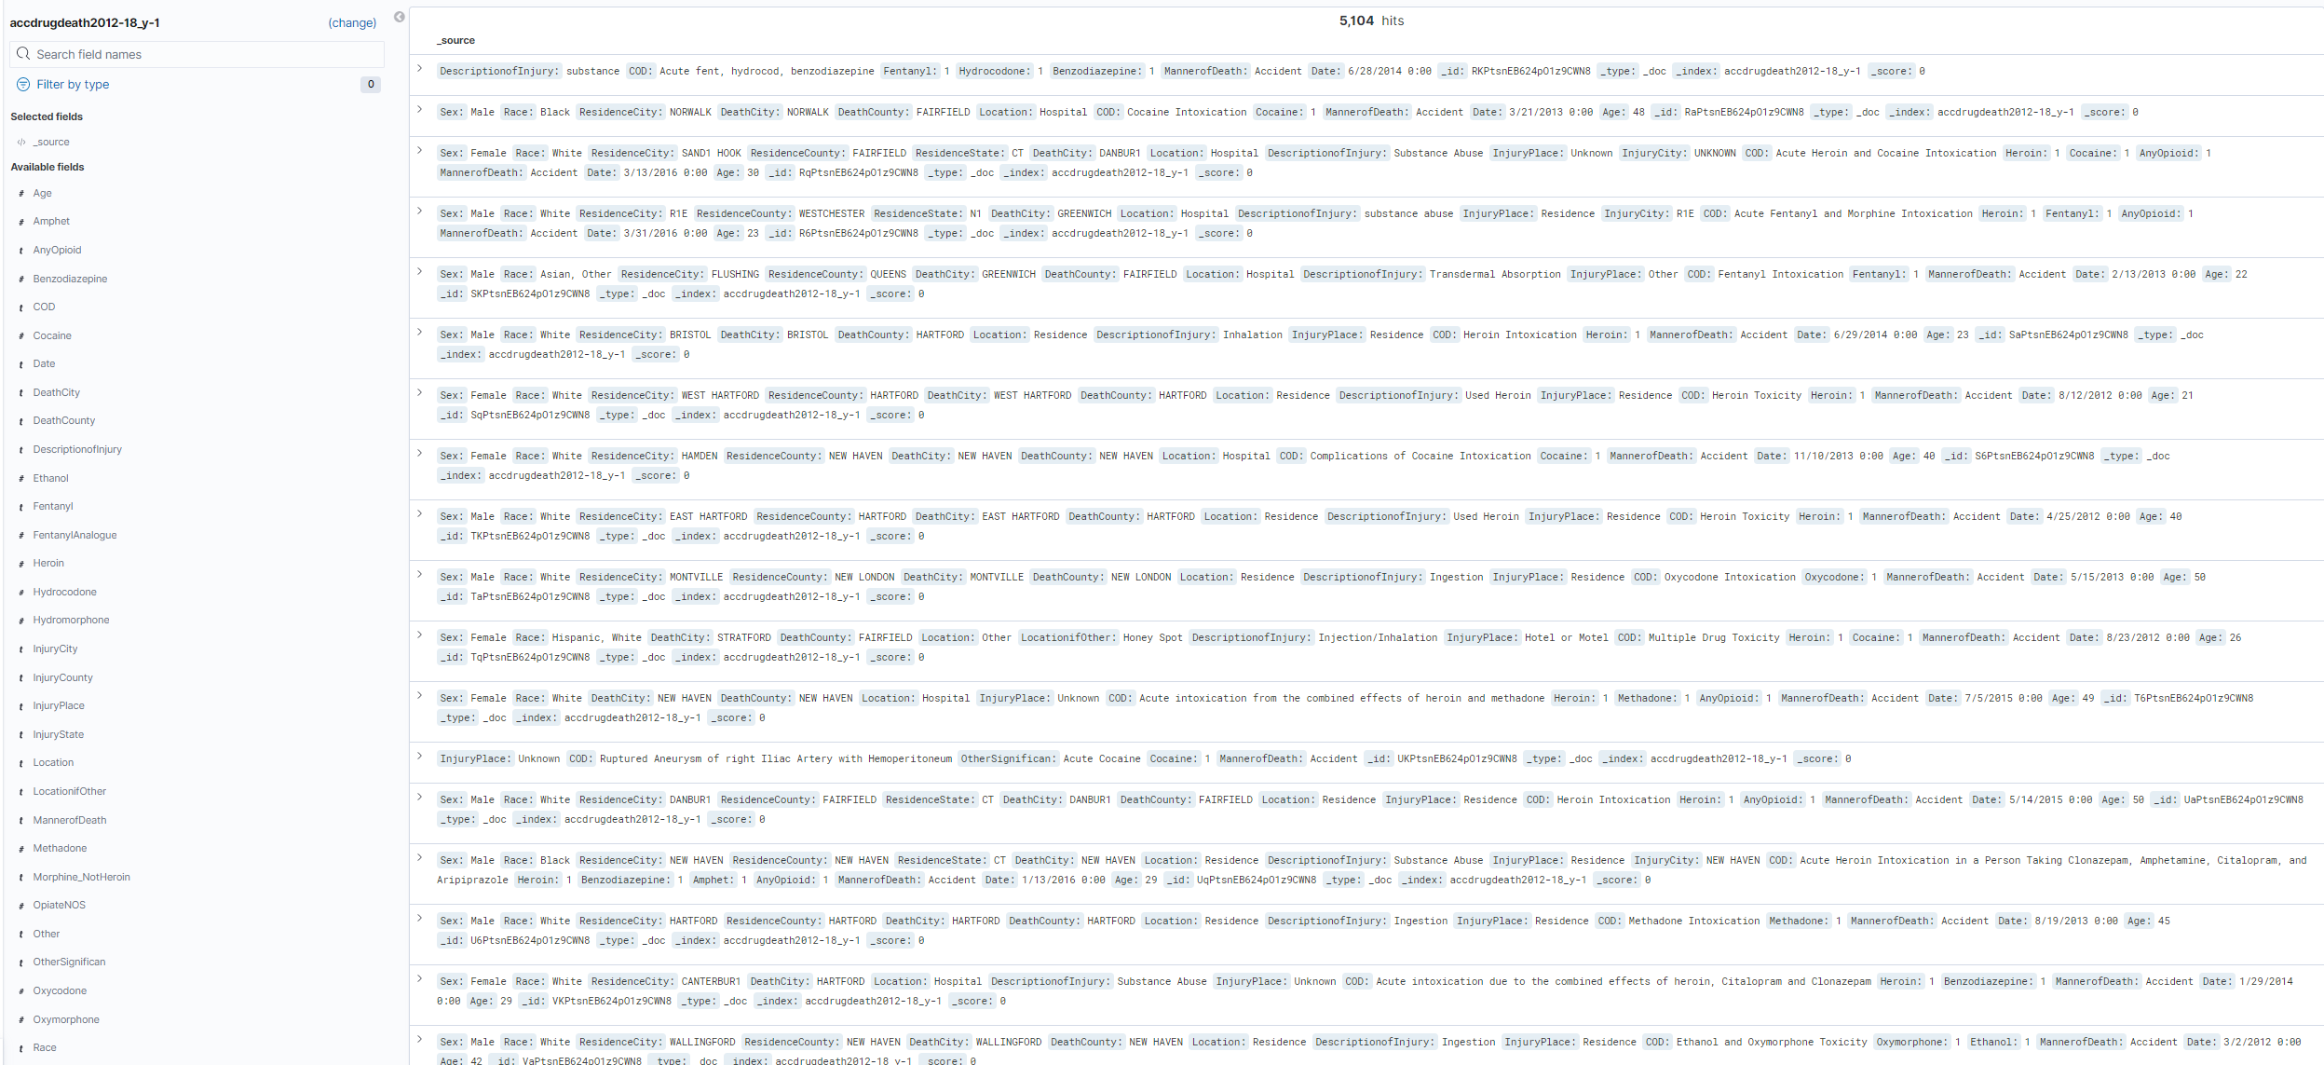

Figure 1. Main Features

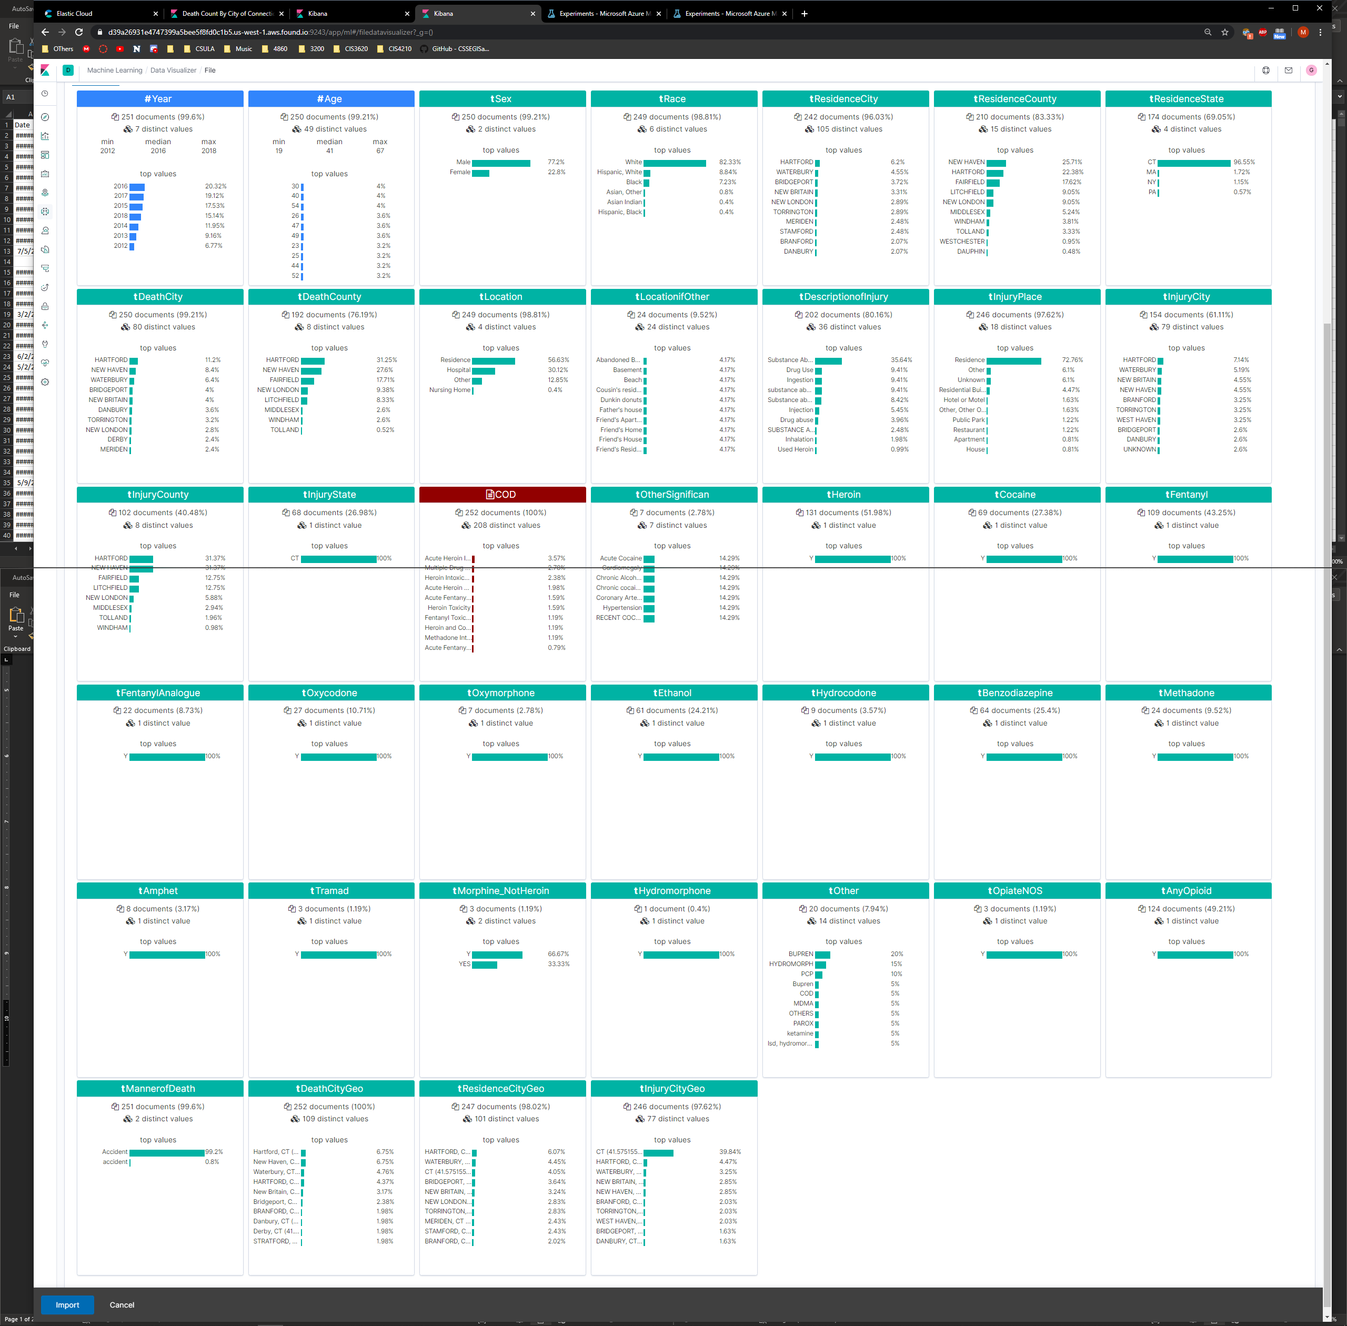

Figure 2. Main Features

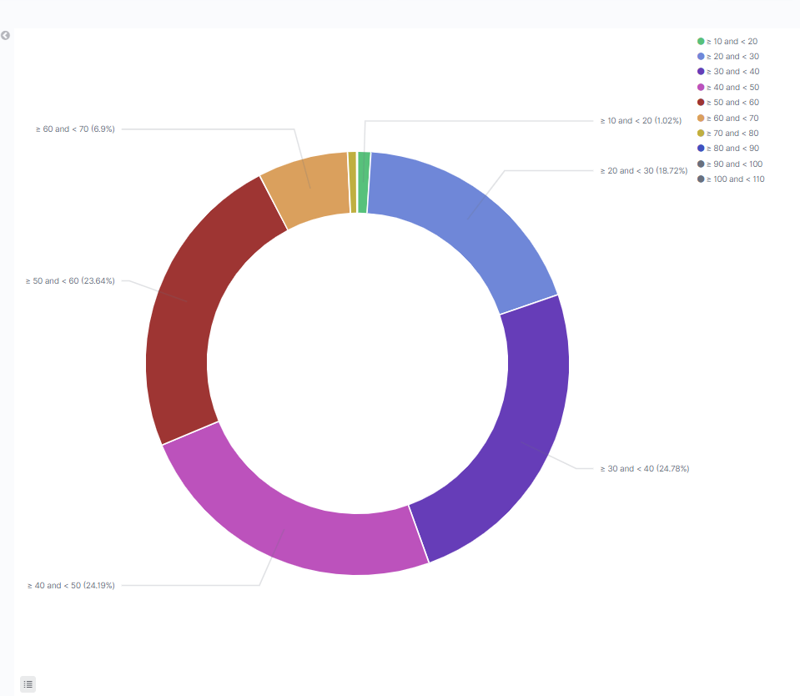

Figure 3. Ave Age of Drug Overdose per drug

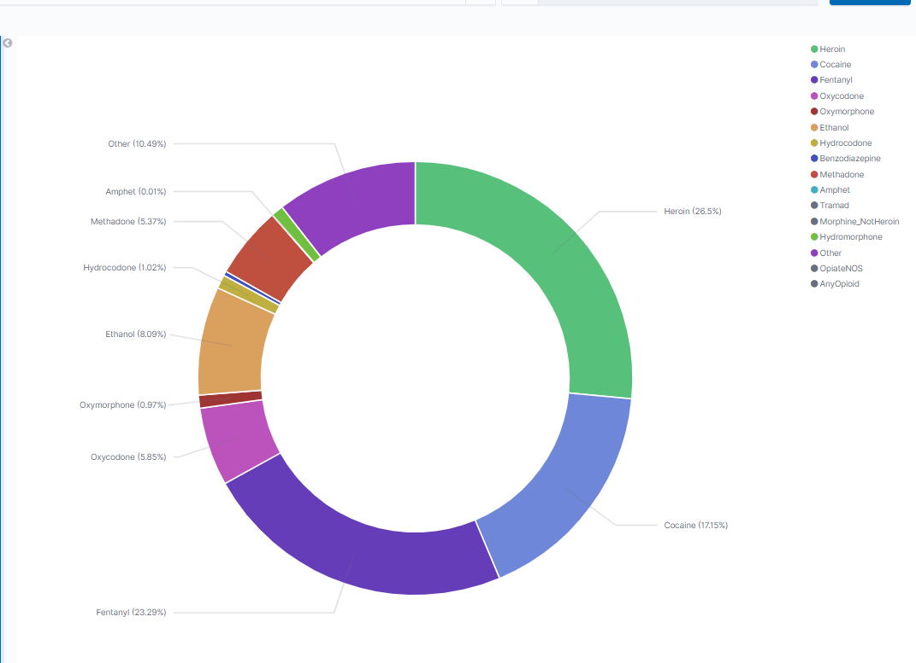 Figure 4. Drugs type and percentage of usage

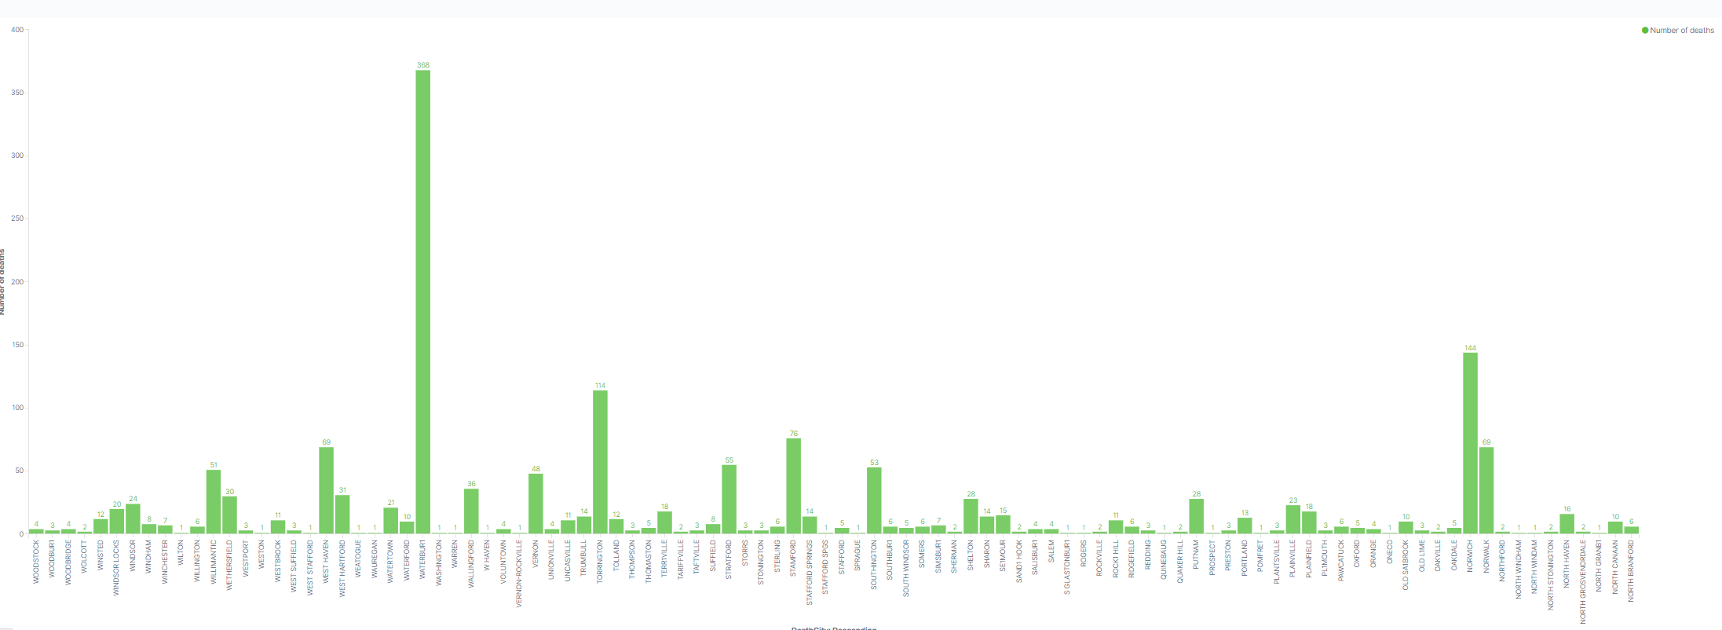 Figure 5. Death by city

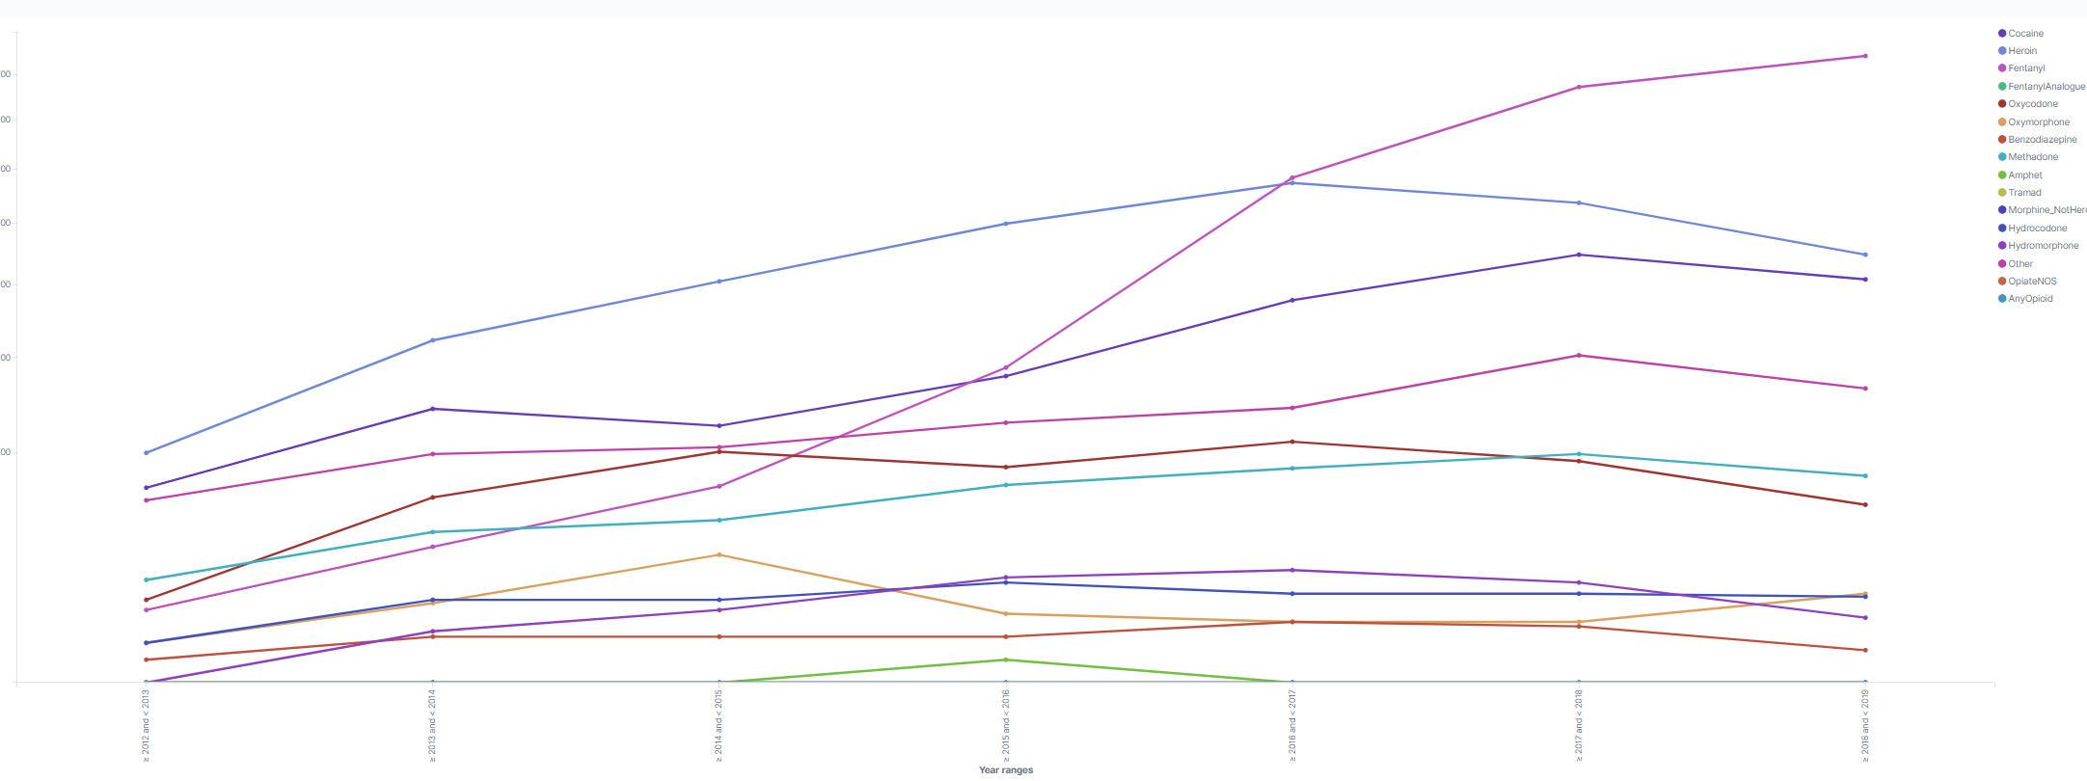

Figure 6. Drug Usage by years

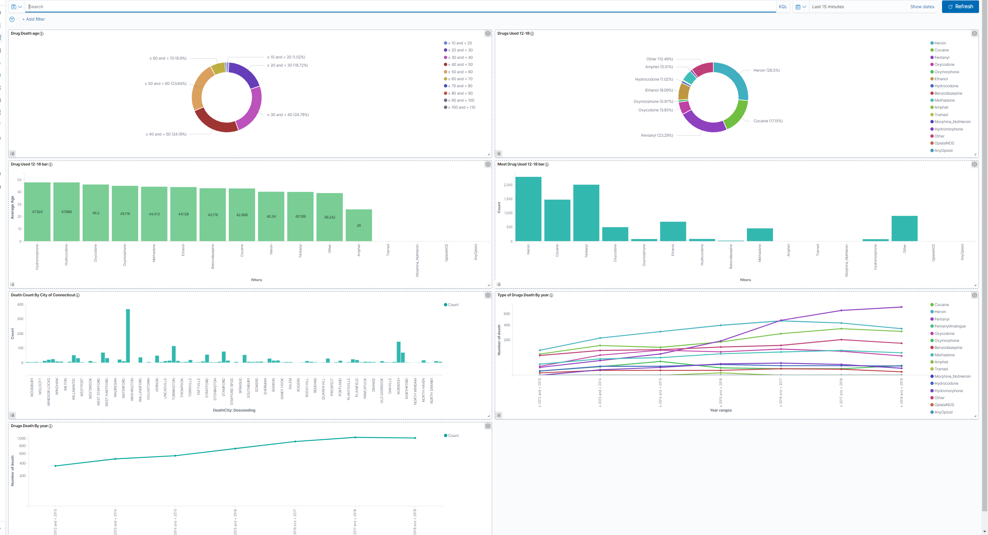

Figure 7. Dashboard [8]

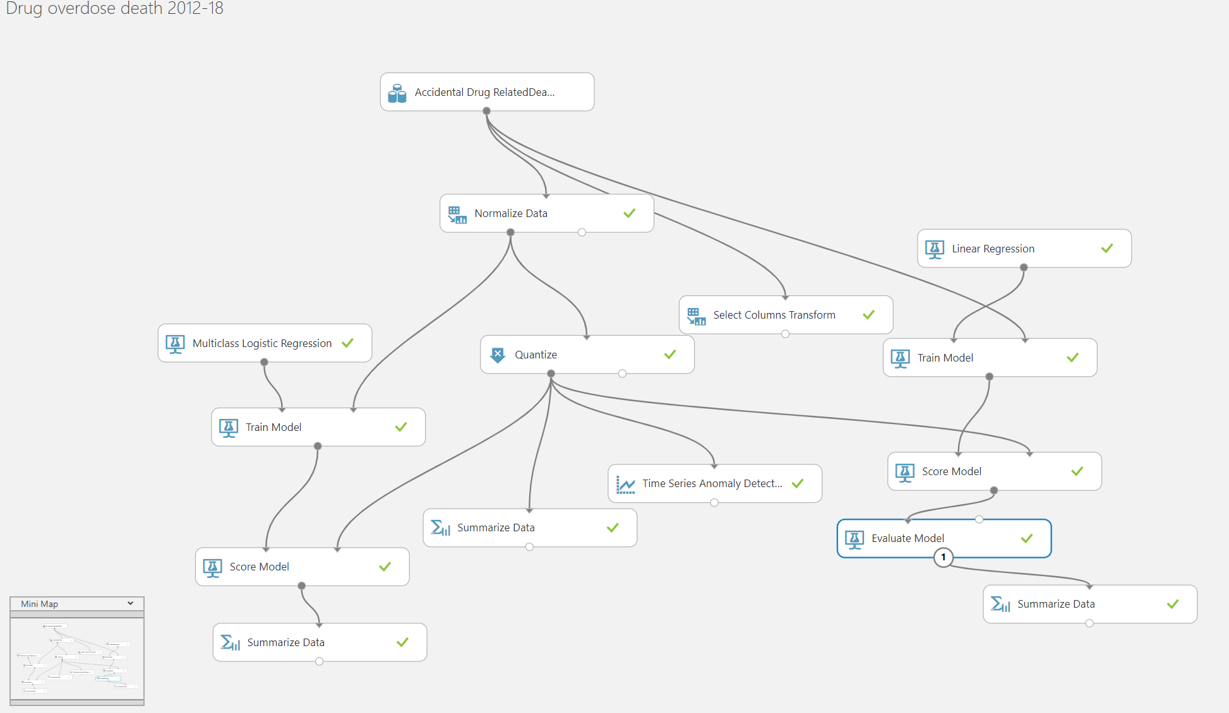

Figure 8. [6]

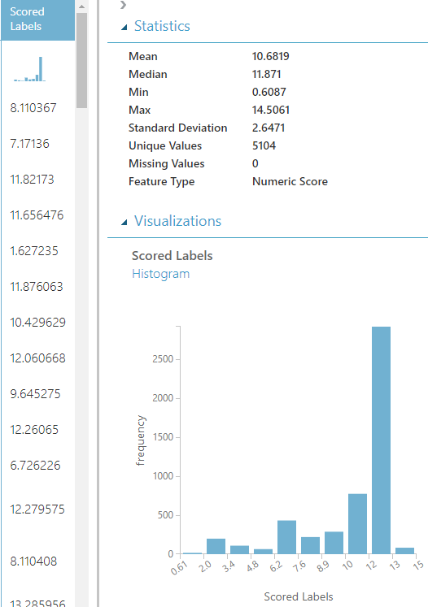

Figure 9.

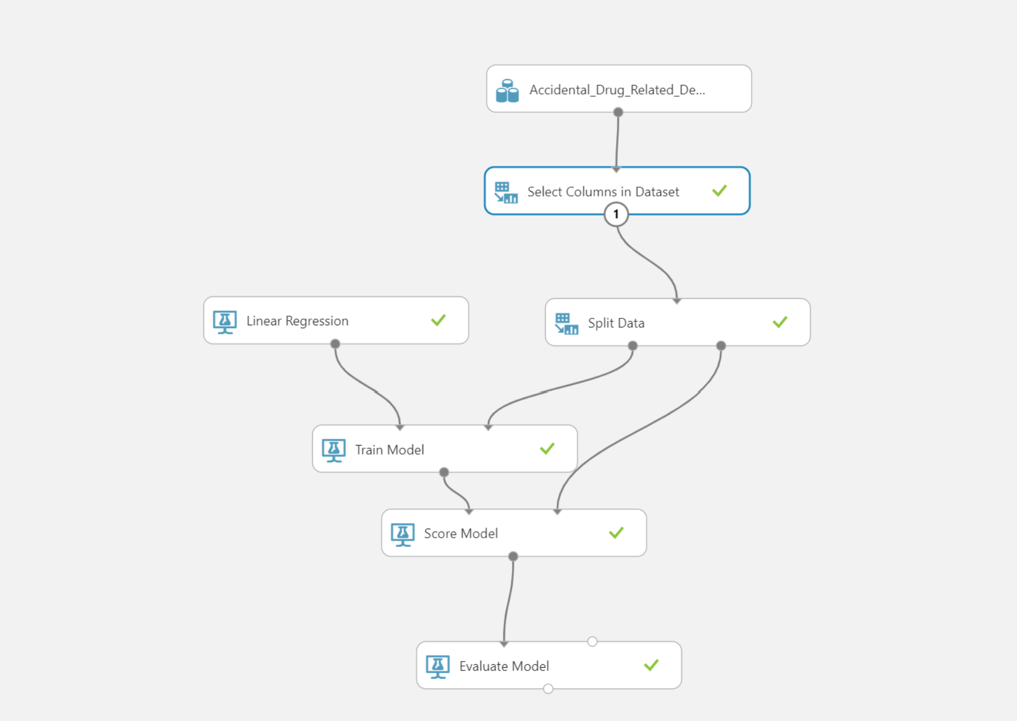Figure 10. [7]

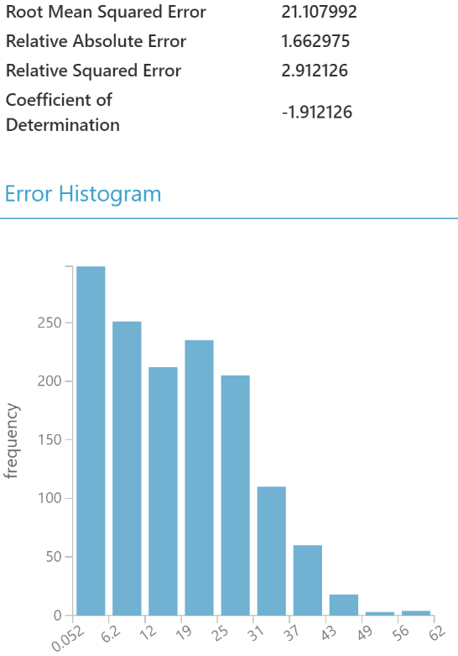

Figure 11.

**5. Submission Process**

### References

[1]Data.gov (2019). “Accidental Drug Related Deaths 2012-2018.” Data.gov. Web. Access: 3/27/2020 link: https://catalog.data.gov/dataset/accidental-drug-related-deaths-january-2012-sept-2015

[2]Martinis, S. Sampson, L. Cerda, M. Galea, S. (2015). “Worldwide Prevalence and Trends in Unintentional Drug Overdose: A Systematic Review of the Literature.” PDF. Web. Access: 4/1/2020. Link: https://ajph.aphapublications.org/doi/pdfplus/10.2105/AJPH.2015.302843

[3]NCHS. (2020). “Drug Overdose Deaths in the United States, 1999-2018.” CDC.gov. NCHS Data Brief No.356. Web. Access: 3/29/2020 link: https://www.cdc.gov/nchs/products/databriefs/db356.htm

[4]Ritchie, H. (2018-2019). “Opioids, cocaine, cannabis, and illicit drugs use.” Our World in Data. Web. Web. Access: 3/31/2020 link: <https://ourworldindata.org/illicit-drug-use>

[5]Git Hub Work - <https://github.com/GianV77/CIS3200Project.git>

[6] Azure Gallery Experiment: <https://gallery.cortanaintelligence.com/Experiment/Drug-overdose-death-2012-18>

[7] Azure Experiment <https://gallery.cortanaintelligence.com/Experiment/Accidental-Drug-Related-Deaths>

[8] Kibana Dashboard: https://d39a26931e4747399a5bee5f8fd0c1b5.us-west-1.aws.found.io:9243/app/kibana#/dashboard/bb739dd0-8a73-11ea-8a60-832e84ee957d?_g=()&_a=(description:'',filters:!(),fullScreenMode:!f,options:(hidePanelTitles:!f,useMargins:!t),panels:!((embeddableConfig:(title:'Drug+Used+12-18+bar',vis:(legendOpen:!f)),gridData:(h:15,i:ea4471ac-a988-4c62-91cf-0f9e249b5b7d,w:24,x:0,y:15),id:'1ea8b970-8732-11ea-8a60-832e84ee957d',panelIndex:ea4471ac-a988-4c62-91cf-0f9e249b5b7d,title:'Drug+Used+12-18+bar',type:visualization,version:'7.5.2'),(embeddableConfig:(),gridData:(h:15,i:aefdfcb9-c063-40a6-bae2-8c11048eefa8,w:24,x:24,y:0),id:'042cbed0-8731-11ea-8a60-832e84ee957d',panelIndex:aefdfcb9-c063-40a6-bae2-8c11048eefa8,type:visualization,version:'7.5.2'),(embeddableConfig:(),gridData:(h:15,i:b048a106-48f0-460a-9ab0-b33821b32eba,w:24,x:0,y:30),id:'2a9c6010-8a66-11ea-8a60-832e84ee957d',panelIndex:b048a106-48f0-460a-9ab0-b33821b32eba,type:visualization,version:'7.5.2'),(embeddableConfig:(legendOpen:!t,vis:(legendOpen:!f)),gridData:(h:15,i:'7e5c243f-92f1-45f8-9b35-2545b079bb27',w:24,x:24,y:15),id:'30dea8d0-8a65-11ea-8a60-832e84ee957d',panelIndex:'7e5c243f-92f1-45f8-9b35-2545b079bb27',type:visualization,version:'7.5.2'),(embeddableConfig:(),gridData:(h:15,i:'81fae6fd-8227-4fa6-814c-dcf0f5893987',w:24,x:0,y:45),id:'9ae0f3c0-8a72-11ea-8a60-832e84ee957d',panelIndex:'81fae6fd-8227-4fa6-814c-dcf0f5893987',type:visualization,version:'7.5.2'),(embeddableConfig:(),gridData:(h:15,i:'4d39c1d0-5001-4171-ace5-385a1ebcd259',w:24,x:24,y:30),id:'4fd47980-8a6b-11ea-8a60-832e84ee957d',panelIndex:'4d39c1d0-5001-4171-ace5-385a1ebcd259',type:visualization,version:'7.5.2'),(embeddableConfig:(),gridData:(h:15,i:'15907da2-b053-4558-bfcb-e44ec7ce528d',w:24,x:0,y:0),id:e4f63990-8a75-11ea-8a60-832e84ee957d,panelIndex:'15907da2-b053-4558-bfcb-e44ec7ce528d',type:visualization,version:'7.5.2')),query:(language:kuery,query:''),timeRestore:!f,title:'Drugs+Death+Overdose+Connecticut+2012-18',viewMode:view)

[8] Kibana Dashboard

User: Gia

Pass: mggv16